**Importance of AWS**

**Module 1: Introduction to Amazon Web Services**

* Summarize the benefits of AWS
* Describe differences between on-demand delivery and cloud deployments
* Summarize the pay-as-you-go pricing model

**Module 2: Compute in the Cloud**

* Describe the benefits of Amazon Elastic Compute Cloud (Amazon EC2) at a basic level
* Identify the different Amazon EC2 instance types
* Differentiate between the various billing options for Amazon EC2
* Describe the benefits of Amazon EC2 Auto Scaling
* Summarize the benefits of Elastic Load Balancing
* Give an example of the uses for Elastic Load Balancing
* Summarize the differences between Amazon Simple Notification Service (Amazon SNS) and Amazon Simple Queue Services (Amazon SQS)
* Summarize additional AWS compute options

**Module 3: Global Infrastructure and Reliability**

* Summarize the benefits of the AWS Global Infrastructure
* Describe the basic concept of Availability Zones
* Describe the benefits of Amazon CloudFront and Edge locations
* Compare different methods for provisioning AWS services

**Module 4: Networking**

* Describe the basic concepts of networking
* Describe the difference between public and private networking resources
* Explain a virtual private gateway using a real-life scenario
* Explain a virtual private network (VPN) using a real-life scenario
* Describe the benefit of AWS Direct Connect
* Describe the benefit of hybrid deployments
* Describe the layers of security used in an IT strategy
* Describe which services are used to interact with the AWS global network

**Module 5: Storage and Databases**

* Summarize the basic concept of storage and databases
* Describe benefits of Amazon Elastic Block Store (Amazon EBS)
* Describe benefits of Amazon Simple Storage Service (Amazon S3)
* Describe the benefits of Amazon Elastic File System (Amazon EFS)
* Summarize various storage solutions
* Describe the benefits of Amazon Relational Database Service (Amazon RDS)
* Describe the benefits of Amazon DynamoDB
* Summarize various database services

**Module 6: Security**

* Explain the benefits of the shared responsibility model
* Describe multi-factor authentication (MFA)
* Differentiate between the AWS Identity and Access Management (IAM) security levels
* Describe security policies at a basic level
* Explain the benefits of AWS Organizations
* Summarize the benefits of compliance with AWS
* Explain primary AWS security services at a basic level

**Module 7: Monitoring and Analytics**

* Summarize approaches to monitoring your AWS environment
* Describe the benefits of Amazon CloudWatch
* Describe the benefits of AWS CloudTrail
* Describe the benefits of AWS Trusted Advisor

**Module 8: Pricing and Support**

* Understand AWS pricing and support models
* Describe the AWS Free Tier
* Describe key benefits of AWS Organizations and consolidated billing
* Explain the benefits of AWS Budgets
* Explain the benefits of AWS Cost Explorer
* Explain the primary benefits of the AWS Pricing Calculator
* Distinguish between the various AWS Support Plans
* Describe the benefits of AWS Marketplace

**Module 9: Migration and Innovation**

* Understand migration and innovation in the AWS Cloud
* Summarize the AWS Cloud Adoption Framework (AWS CAF)
* Summarize six key factors of a cloud migration strategy
* Describe the benefits of various AWS data migration solutions, such as AWS Snowcone, AWS Snowball, and AWS Snowmobile
* Summarize the broad scope of innovative solutions that AWS offers

**Module 10: The Cloud Journey**

* Summarize the five pillars of the AWS Well-Architected Framework
* Explain the six benefits of cloud computing

**Module 11: AWS Certified Cloud Practitioner Basics**

* Determine resources for preparing for the AWS Certified Cloud Practitioner examination
* Describe benefits of becoming AWS Certified

**Amazon Web Services (AWS CLF-C01)**

<https://explore.skillbuilder.aws/learn/course/external/view/elearning/134/aws-cloud-practitioner-essentials>

<https://explore.skillbuilder.aws/learn/course/9449/exam-prep-aws-certified-cloud-practitioner-clf-c01>

**Amazon Web Services (AWS CLF-C02):**

**First mentoring session -** [**https://capgemini-my.sharepoint.com/:v:/p/amal_thambi/EUn6G4ekjjRJlpy-WkDvo34BUhanQbHj2CoSffswH8Doog?referrer=Teams.TEAMS-ELECTRON&referrerScenario=MeetingChicletGetLink.view.view**](https://capgemini-my.sharepoint.com/:v:/p/amal_thambi/EUn6G4ekjjRJlpy-WkDvo34BUhanQbHj2CoSffswH8Doog?referrer=Teams.TEAMS-ELECTRON&referrerScenario=MeetingChicletGetLink.view.view)

**Second mentoring session -** [**https://capgemini-my.sharepoint.com/:v:/p/amal_thambi/Ea75EpkfpkdIqymmMNOIxRUBO7SL3xpP44IhPxYdHcIm0A?referrer=Teams.TEAMS-ELECTRON&referrerScenario=MeetingChicletGetLink.view.view**](https://capgemini-my.sharepoint.com/:v:/p/amal_thambi/Ea75EpkfpkdIqymmMNOIxRUBO7SL3xpP44IhPxYdHcIm0A?referrer=Teams.TEAMS-ELECTRON&referrerScenario=MeetingChicletGetLink.view.view)

**Third mentoring session -** [**https://capgemini-my.sharepoint.com/:v:/p/amal_thambi/EXt0EPlp-bJLpa9Ifkhldv8B4BX-_lgL67uFUB7rrQSAcA?referrer=Teams.TEAMS-ELECTRON&referrerScenario=MeetingChicletGetLink.view.view**](https://capgemini-my.sharepoint.com/:v:/p/amal_thambi/EXt0EPlp-bJLpa9Ifkhldv8B4BX-_lgL67uFUB7rrQSAcA?referrer=Teams.TEAMS-ELECTRON&referrerScenario=MeetingChicletGetLink.view.view)

**Difference of local deployment and Aws deployment**

**Local Deployment** **Aws Deployment**

Everything runs locally and same machine one service=one responsibility

Files stored on server Files served from s3

Database on same server as application Database as a service

Connections done manually Connections done AWS software development kit

For AWS have 170+ services, how can interact with these services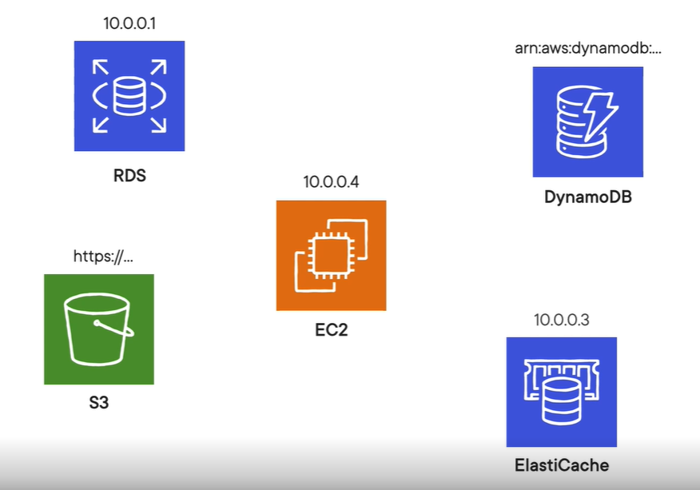

**The core of AWS is Elastic cloud computing (EC2)**

**Amazon Elastic Cloud Compute (Amazon EC2):**

Amazon Elastic Compute Cloud (Amazon EC2) provides secure, resizable compute capacity in the cloud as Amazon EC2 instances.

Imagine you are responsible for the architecture of your company's resources and need to support new websites.

**With traditional on-premises resources, you must do the following:**

* Spend money upfront to purchase hardware.
* Wait for the servers to be delivered to you.
* Install the servers in your physical data centre.
* Make all the necessary configurations.

**By comparison, with an Amazon EC2 instance you can use a virtual server to run applications in the AWS Cloud.**

* You can provision and launch an Amazon EC2 instance within minutes.
* You can stop using it when you have finished running a workload.
* You pay only for the compute time you use when an instance is running, not when it is stopped or terminated.
* You can save costs by paying only for server capacity that you need or want.

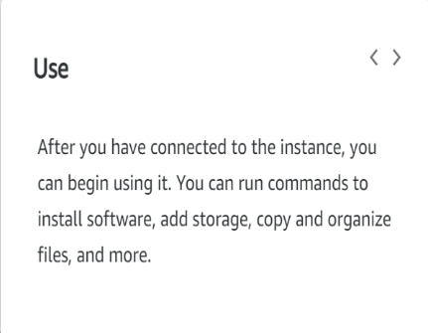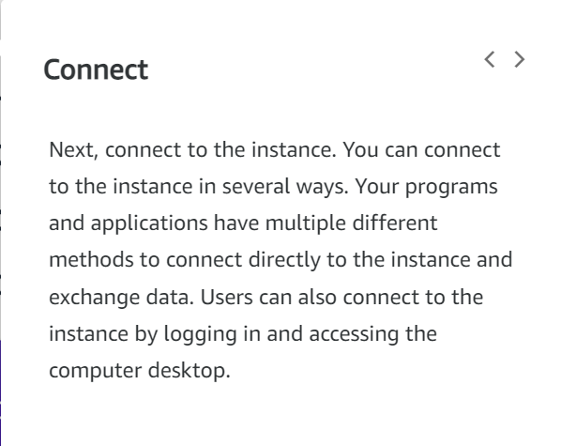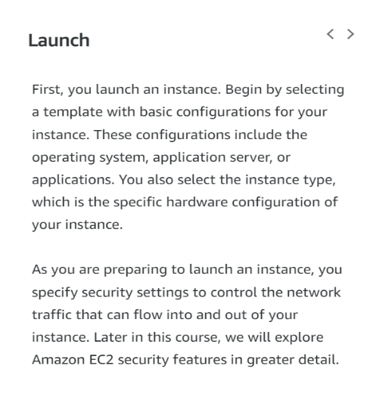**How Amazon EC2 works:**

**Amazon EC2 instance types:**

Amazon EC2 instance types are optimized for different tasks.

When selecting an instance type, consider the specific needs of your workloads and applications. This might include requirements for compute, memory, or storage capabilities.

1. 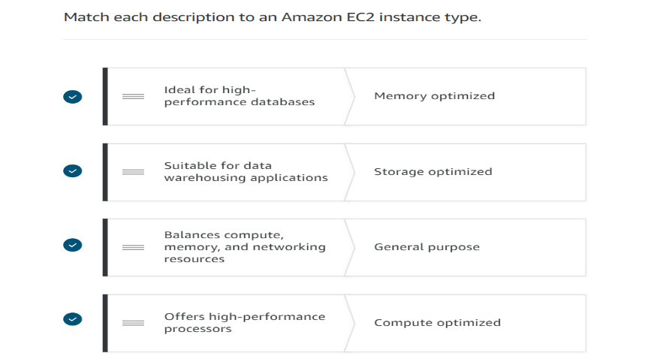**General purpose Instance**

It is used balance compute, memory, and   
 networking resources.

1. **Compute optimized Instance**

Offers high-performance processors

1. **Memory optimized Instance**

Ideal for high performance databases

1. **Storage optimized Instance**

Suitable for data warehousing applications

1. **Accelerated computing Instance**

Use hardware accelerators, or co-processors, or  
 data pattern machine

**Amazon EC2 prising:**

Amazon EC2 purchase options

1. **On-Demand**

* It's the pay-as-you-go model
* Standard rate-no discount; no commitments; dev/test, sort term or unpredictable workloads.

1. **Savings Plans**

* Savings Plans are a flexible pricing model that offers low prices on EC2 and Faregate usage, in exchange for a commitment to a consistent amount of usage (measured in $/hour) for a one - or three-year term.

1. **Reserved Instances**

* It purchases are one of the easiest ways to start reducing cloud spends.
* One- or three-year commitment.
* In return for that long-term commitment, AWS gives a hefty discount of up to 72% off compared to the On-Demand prices.

1. **Spot Instances**

* It allows you to take advantage of Amazon's 'extra' capacity.
* They are offered at a deep discount of up-to 90% off the On-Demand EC2 prices.
* Spot Instance are flexible start and end time.

1. **Dedicated hosts**

* A Dedicated Host is a physical EC2 server dedicated for your use.
* Dedicated Hosts can help you reduce costs by allowing you to use your existing server-bound software licenses, including Windows Server, SQL Server, and SUSE Linux Enterprise Server (subject to your license terms), and can also help you meet compliance requirements.

**Scaling Amazon EC2:**

**Scalability**

Scalability involves beginning with only the resources you need and designing your architecture to automatically respond to changing demand by scaling out or in. As a result, you pay for only the resources you use. You don’t have to worry about a lack of computing capacity to meet your customers’ needs. If you wanted the scaling process to happen automatically, which AWS service would you use? The AWS service that provides this functionality for Amazon EC2 instances is Amazon EC2 Auto Scaling**.**

**Amazon EC2 Auto Scaling:**

Amazon EC2 Auto Scaling enables you to automatically add or remove Amazon EC2 instances in response to changing application demand.

By automatically scaling your instances in and out as needed, you can maintain a greater sense of application availability. Within Amazon EC2 Auto Scaling, you can use two approaches: dynamic scaling and predictive scaling.

* Dynamic scaling responds to changing demand.
* Predictive scaling automatically schedules the right number of Amazon EC2 instances based on predicted demand.

**Ex**: When you create an Auto Scaling group, you can set the minimum number of Amazon EC2 instances. The minimum capacity is the number of Amazon EC2 instances that launch immediately after you have created the Auto Scaling group. In this example, the Auto Scaling group has a minimum capacity of one Amazon EC2 instance.

**Elastic Load Balancing:**

Elastic Load Balancing is the AWS service that automatically distributes incoming application traffic across multiple resources, such as Amazon EC2 instances.

A load balancer acts as a single point of contact for all incoming web traffic to your Auto Scaling group. This means that as you add or remove Amazon EC2 instances in response to the amount of incoming traffic, these requests route to the load balancer first. Then, the requests spread across multiple resources that will handle them.

**For example**, if you have multiple Amazon EC2 instances, Elastic Load Balancing distributes the workload across the multiple instances so that no single instance must carry the bulk of it. Although Elastic Load Balancing and Amazon EC2 Auto Scaling are separate services, they work together to help ensure that applications running in Amazon EC2 can provide high performance and availability.

**Low-demand period:**

Here’s an example of how Elastic Load Balancing works. Suppose that a few customers have come to the coffee shop and are ready to place their orders.

If only a few registers are open, this matches the demand of customers who need service. The coffee shop is less likely to have open registers with no customers. In this example, you can think of the registers as Amazon EC2 instances.

**High-demand period:**

Throughout the day, as the number of customers increases, the coffee shop opens more registers to accommodate them. In the diagram, the Auto Scaling group represents this.

Additionally, a coffee shop employee directs customers to the most appropriate register so that the number of requests can evenly distribute across the open registers. You can think of this coffee shop employee as a load balancer.

**Messaging and queuing:**

Monolithic application and microservices:

**Monolithic application:**

Applications are made of multiple components. The components communicate with each other to transmit data, fulfil requests, and keep the application running.

Suppose that you have an application with tightly coupled components. These components might include databases, servers, the user interface, business logic, and so on. This type of architecture can be considered a monolithic application.

In this approach to application architecture, if a single component fails, other components fail, and possibly the entire application fails.

To help maintain application availability when a single component fails, you can design your application through a microservices approach.

**Microservices application:**

In a microservices approach, application components are loosely coupled. In this case, if a single component fails, the other components continue to work because they are communicating with each other. The loose coupling prevents the entire application from failing.

When designing applications on AWS, you can take a microservices approach with services and components that fulfil different functions. Two services facilitate application integration: Amazon Simple Notification Service (Amazon SNS) and Amazon Simple Queue Service (Amazon SQS).

**Amazon Simple Notification Service (Amazon SNS):**

Amazon Simple Notification Service (Amazon SNS) is a publish/subscribe service. Using Amazon SNS topics, a publisher publishes messages to subscribers. This is like the coffee shop; the cashier provides coffee orders to the barista who makes the drinks.

In Amazon SNS, subscribers can be web servers, email addresses, AWS Lambda functions, or several other options.

**Amazon Simple Queue Service (Amazon SQS):**

Amazon Simple Queue Service (Amazon SQS) is a message queuing service.

Using Amazon SQS, you can send, store, and receive messages between software components, without losing messages or requiring other services to be available. In Amazon SQS, an application sends messages into a queue. A user or service retrieves a message from the queue, processes it, and then deletes it from the queue.

**AWS CLI (Command line interface) features**

Great for shell shifting, feature complete with console and SDKs, Interact with any service

AWS CLI made for operations engineers more than developers

Usages: Configure local development environment and alternative to console actions.

**AWS SDK (Software Development Kit) features**